How do you even store an infinite number of things in the computer when your computer is going to run out of memory? It turns out that when we talk about an algorithm called the **Support Vector Machine**, there will be a neat mathematical trick that will allow a computer to deal with an infinite number of features.

We also talked about the regression problem, and by regression that means that our goal is to predict a continuous valued output. We talked about the classification problem where the goal is to predict a discrete value output

Supervised Learning

In supervised learning, we are given a data set and already know what our correct output should look like, having the idea that there is a relationship between the input and the output.

Supervised learning problems are categorized into "regression" and "classification" problems. In a regression problem, we are trying to predict results within a continuous output, meaning that we are trying to map input variables to some continuous function. In a classification problem, we are instead trying to predict results in a discrete output. In other words, we are trying to map input variables into discrete categories.

**Example 1:**

Given data about the size of houses on the real estate market, try to predict their price. Price as a function of size is a continuous output, so this is a regression problem.

We could turn this example into a classification problem by instead making our output about whether the house "sells for more or less than the asking price." Here we are classifying the houses based on price into two discrete categories.

**Example 2**:

(a) Regression - Given a picture of a person, we have to predict their age on the basis of the given picture

(b) Classification - Given a patient with a tumor, we have to predict whether the tumor is malignant or benign.

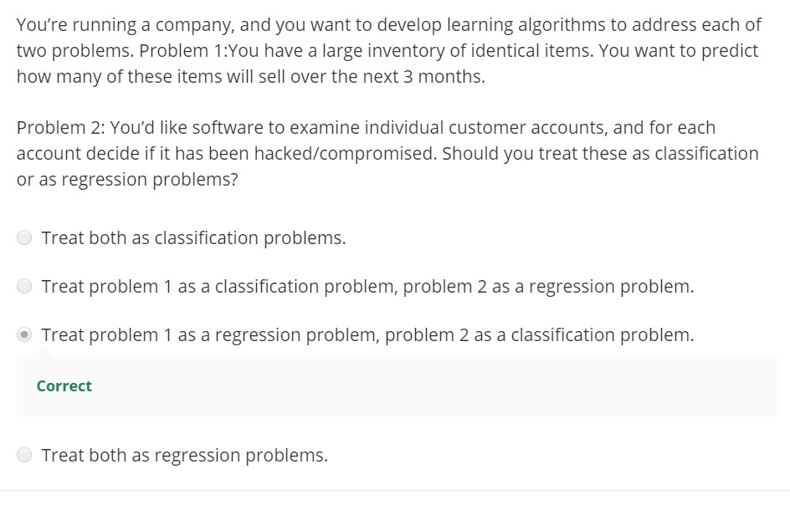

## Unsupervised Learning

**Unsupervised Learning or clustering** is used for a bunch of other applications.

* It's used to organize large computer clusters: I had some friends looking at

large data centers, that is large computer clusters and trying to figure out which machines tend to work together and if you can put those machines together, you can make your data center work more efficiently.

* This second application is on social network analysis: So given knowledge about which friends you email the most or given your Facebook friends or your Google+ circles, can

we automatically identify which are cohesive groups of friends, also which are groups of people that all know each other

* Market segmentation: Many companies have huge databases of customer information.

So, can you look at this customer data set and automatically discover market segments and automatically group your customers into different market segments so that you can automatically and more efficiently sell or market your different market segments together? Again, this is Unsupervised Learning because we have all this customer data, but we don't know in advance what are the market segments and for the customers in our data set, you know, we don't know in advance who is in market segment one, who is in market segment two, and so on. But we have to let the algorithm discover all this just from the data.

* Astronomical data analysis: These clustering algorithms gives surprisingly interesting useful theories of how galaxies are formed. All of these are examples of clustering, which is just one type of Unsupervised Learning.

**Cocktail party problem:**

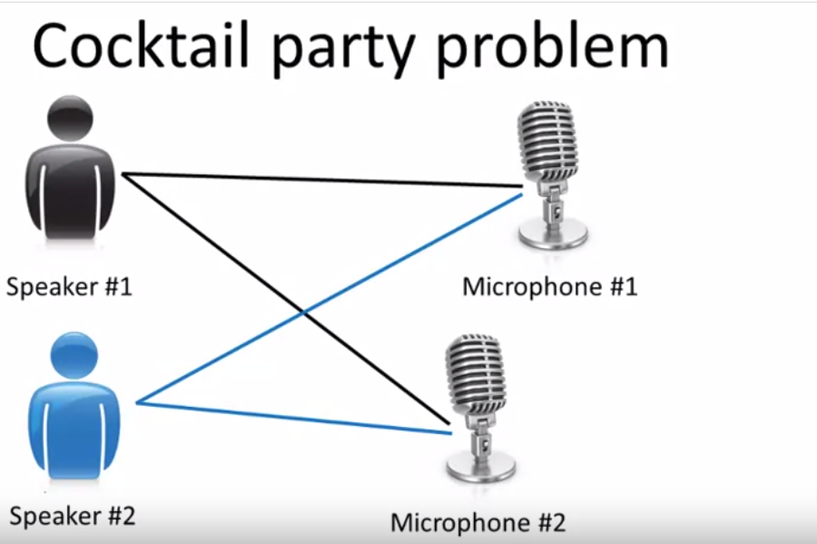

 There's two people counting from one to ten in two languages

So we can do, is take these two microphone recorders and give them to an Unsupervised Learning algorithm called the cocktail party algorithm, and tell the algorithm - find structure in this data for you. And what the algorithm will do is listen to these audio recordings and say, you know it sounds like the two audio recordings are being added together or that have being summed together to produce these recordings that we had. Moreover, what the cocktail party algorithm will do is separate out these two audio sources that were being added or being summed together to form other recordings and, in fact, here's the first output of the cocktail party algorithm. It turns out the algorithm, to do what you just heard, that can be done with one line of code IN OCTAVE.

Unsupervised learning allows us to approach problems with little or no idea what our results should look like. We can derive structure from data where we don't necessarily know the effect of the variables.

We can derive this structure by clustering the data based on relationships among the variables in the data.

With unsupervised learning there is no feedback based on the prediction results.

**Example:**

Clustering: Take a collection of 1,000,000 different genes, and find a way to automatically group these genes into groups that are somehow similar or related by different variables, such as lifespan, location, roles, and so on.

Non-clustering: The "Cocktail Party Algorithm", allows you to find structure in a chaotic environment. (i.e. identifying individual voices and music from a mesh of sounds at a [cocktail party](https://en.wikipedia.org/wiki/Cocktail_party_effect)).

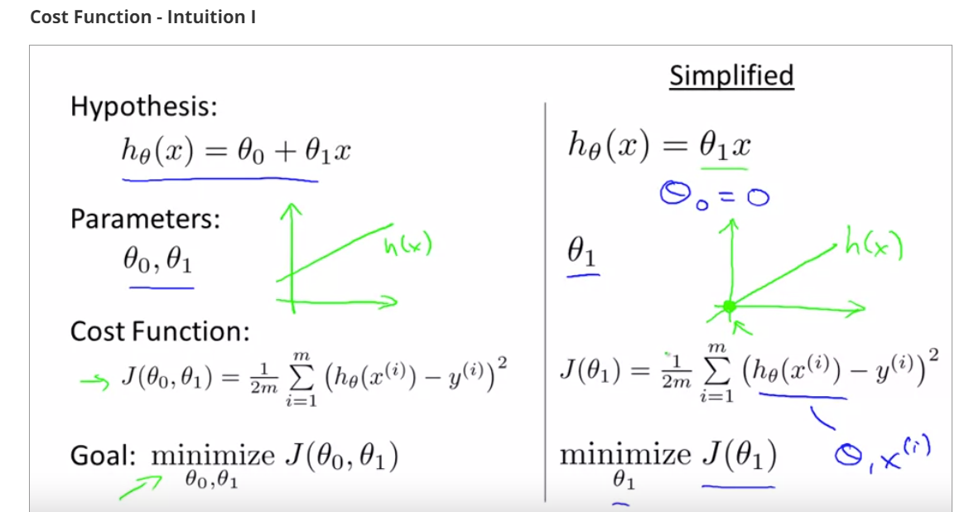

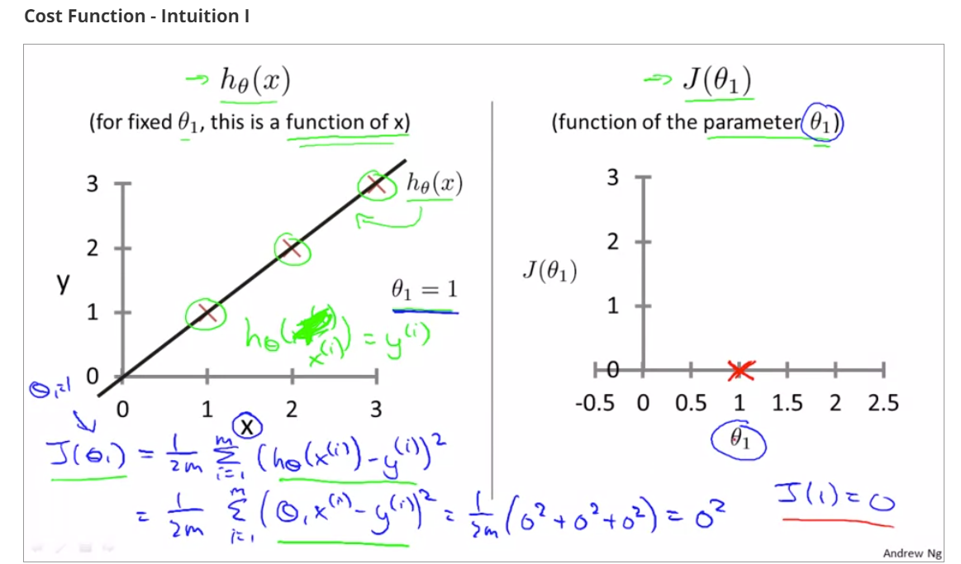

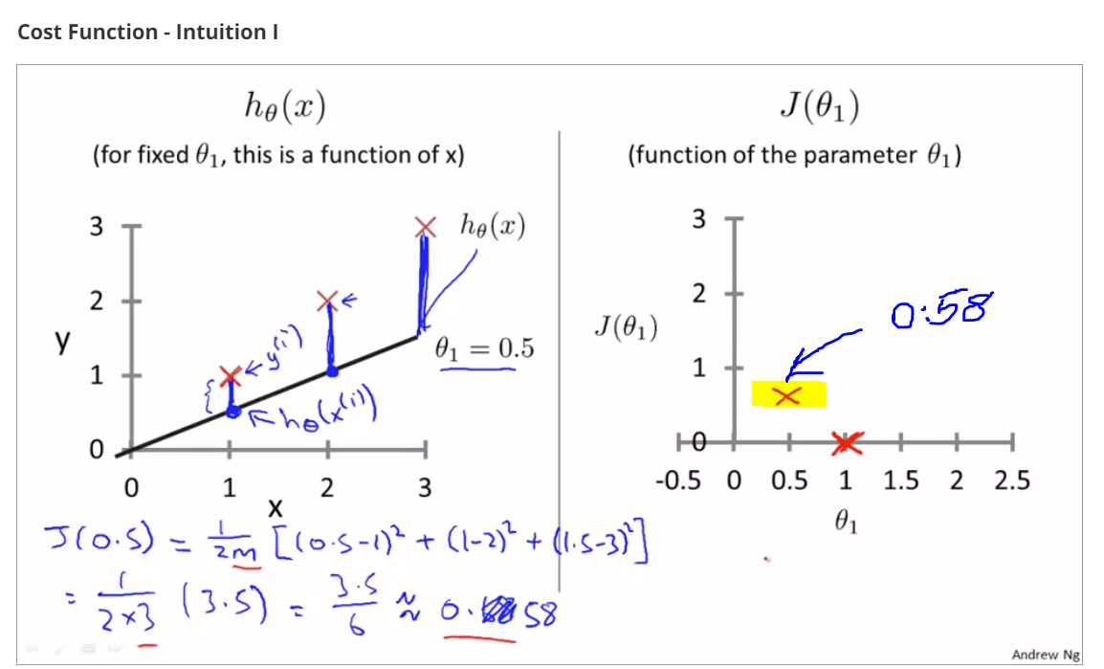

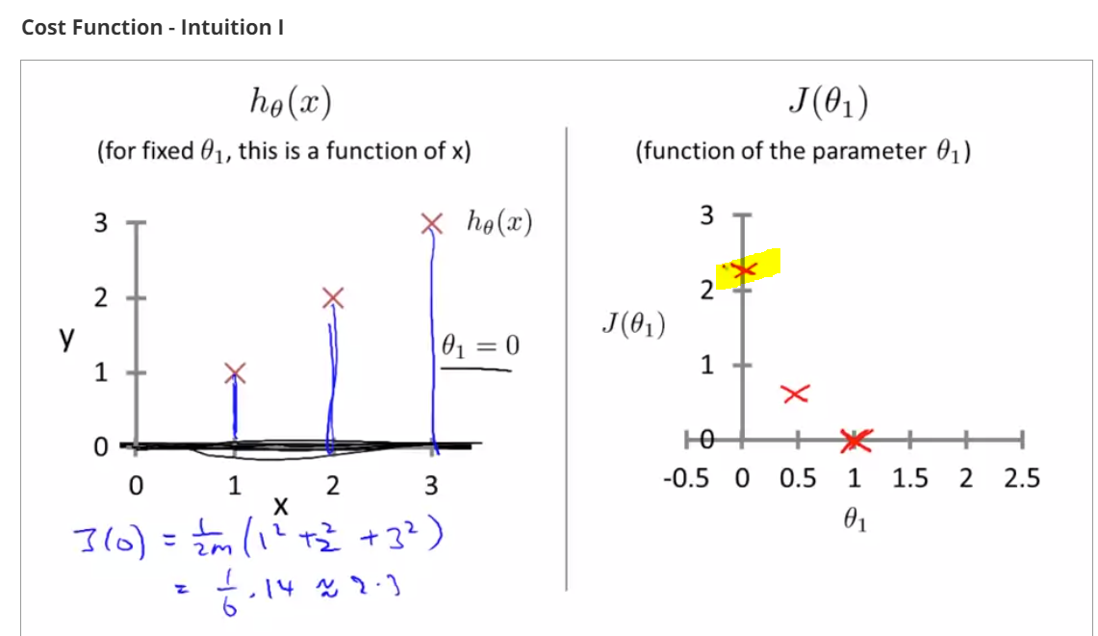

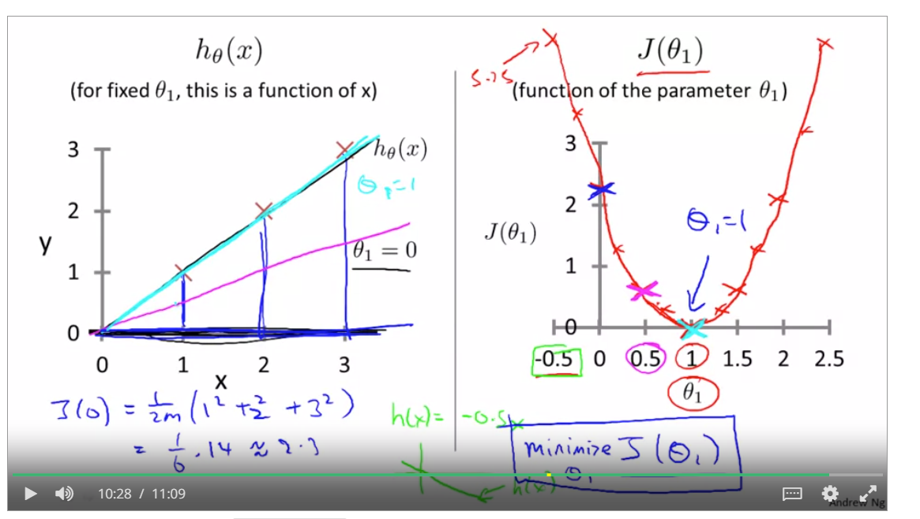

J(Theta 1) is minimum when theta 1 = 1

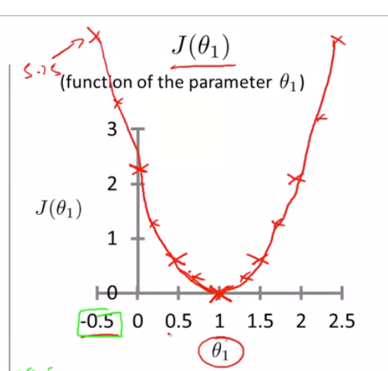

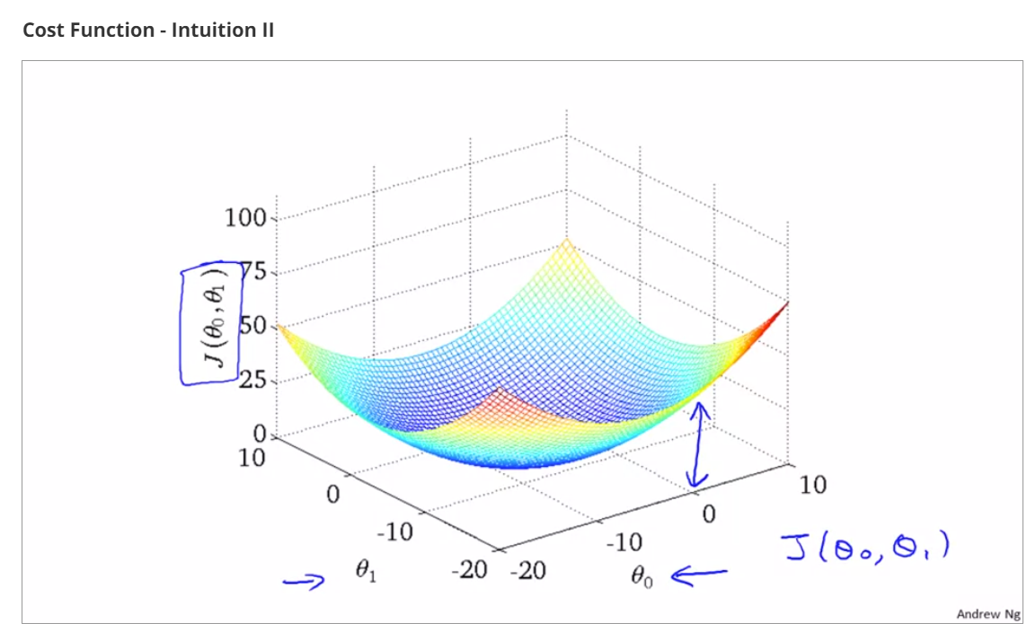

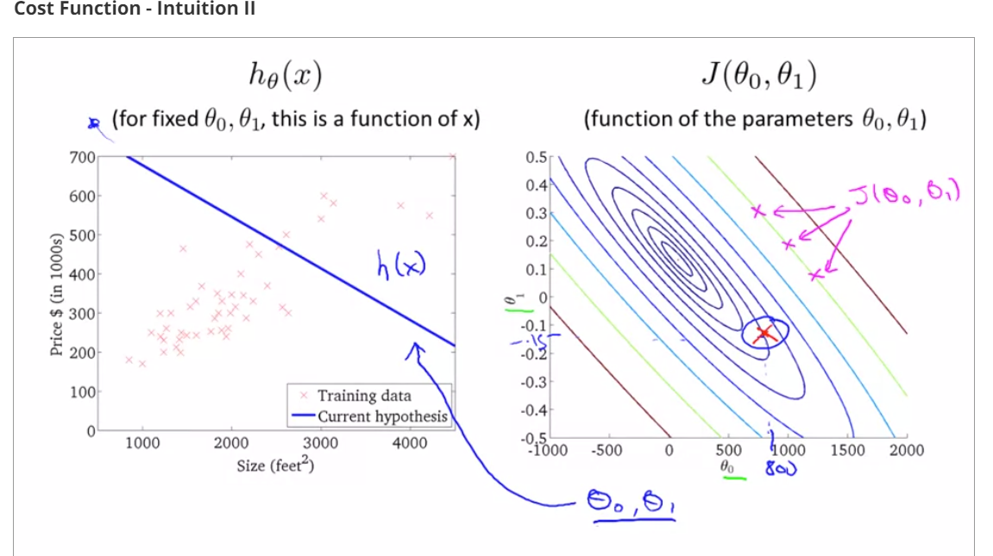

The above hypothesis is not a good fit of data because on the right, the point marked in red is very far from the innermost concentric circle where cost function is minimum.

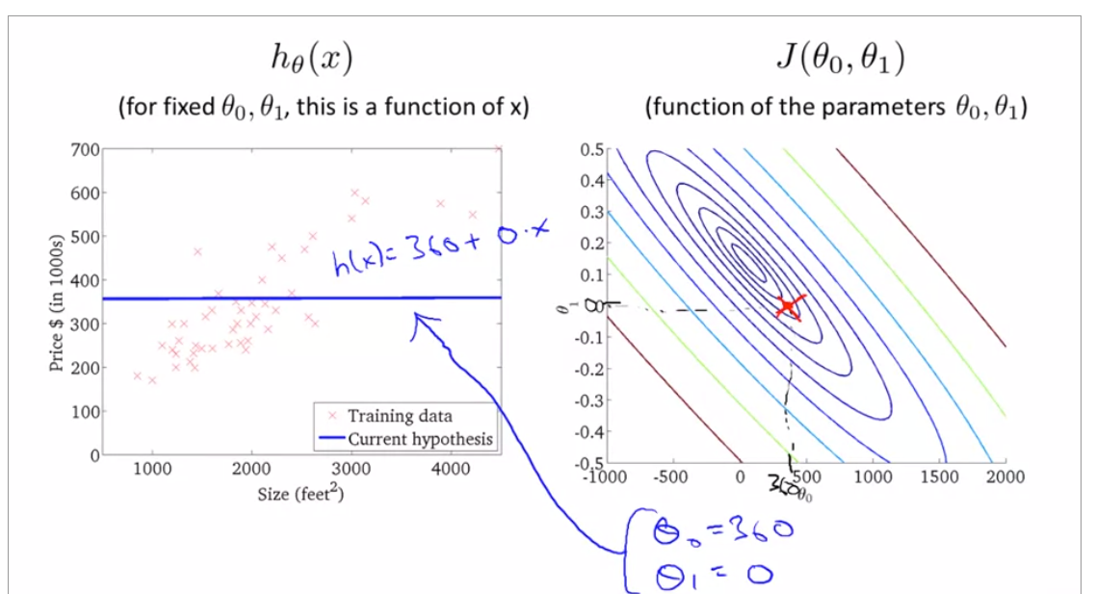

The above hypothesis is better because on the right, the point marked in red is pretty closer to the inner most concentric circle where cost function is minimum.

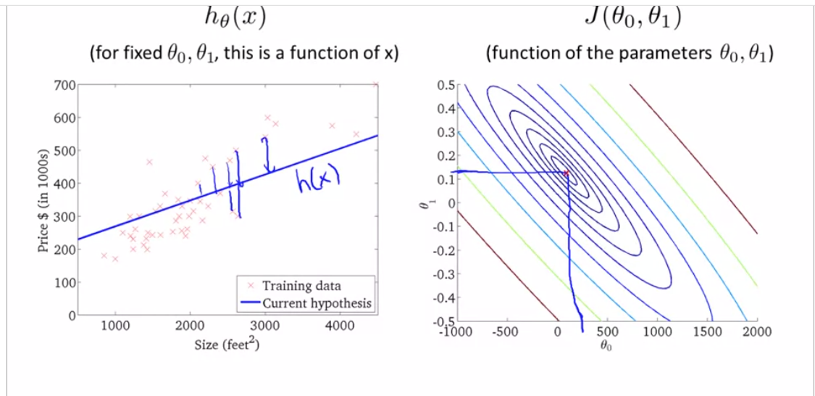

The above hypothesis is almost = minimum but not exactly minimum. The sum of squared errors between actual points(marked as x) and predicted values on h(x) line is almost = 0;

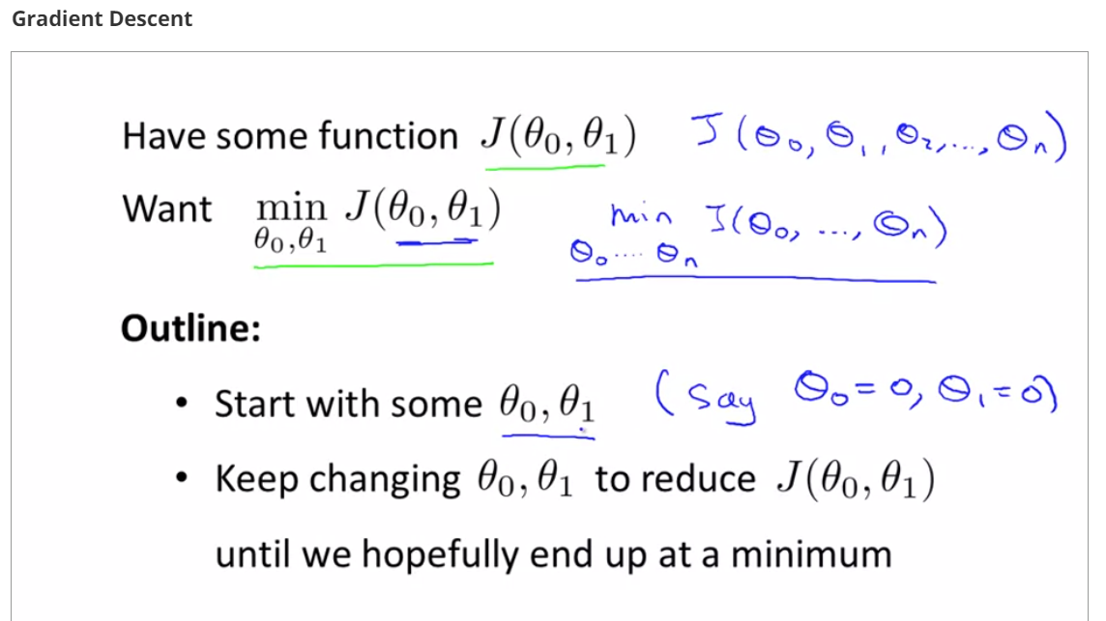

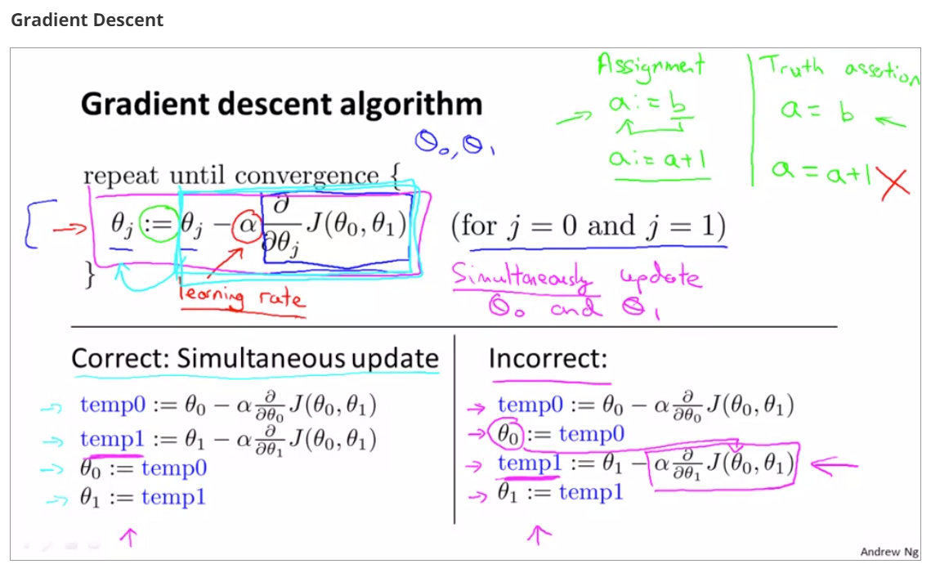

Alpha – small => taking small baby steps down the hill to reach local minima

Alpha is large => taking aggressive descent towards reaching local minima

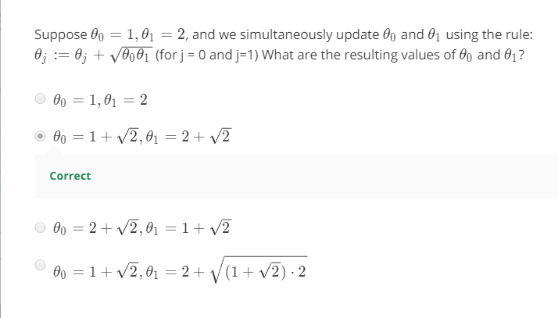

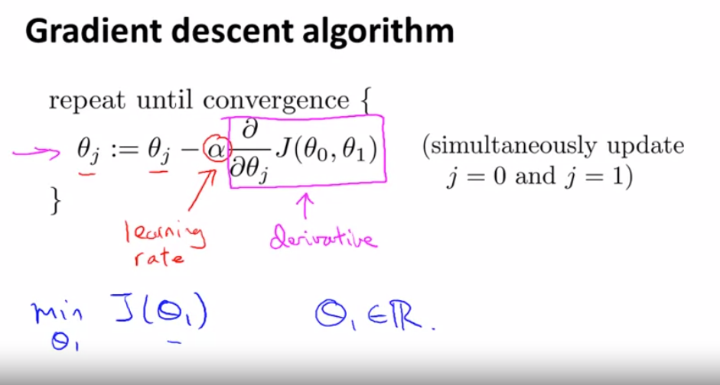

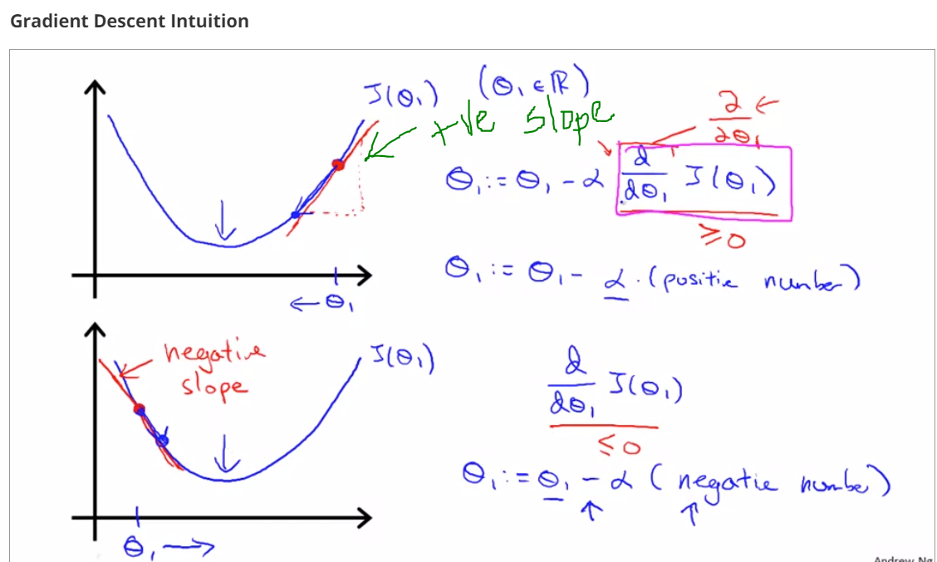

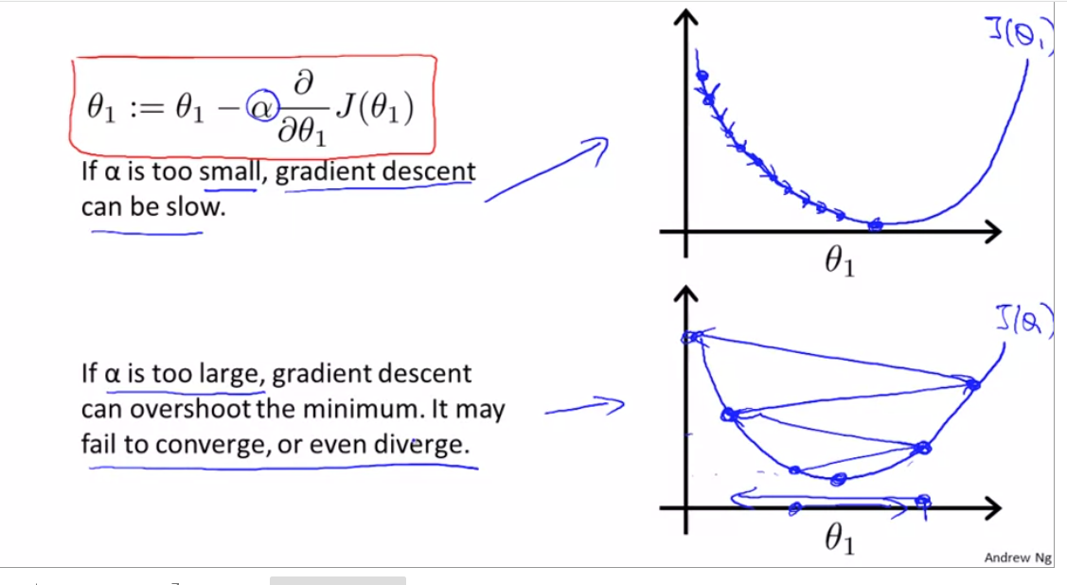

If learning rate is too small, we end up taking these tiny tiny baby steps as you try to get to the minimum. It’s gonna need a lot of steps to get to the minimum and so if alpha is too small gradient descent can be slow because it's gonna take these tiny tiny baby steps and so it's gonna need a lot of steps before it gets anywhere close to the global minimum.

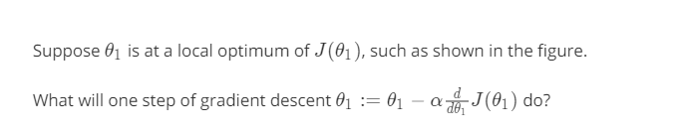

Theta 1 is unchanged

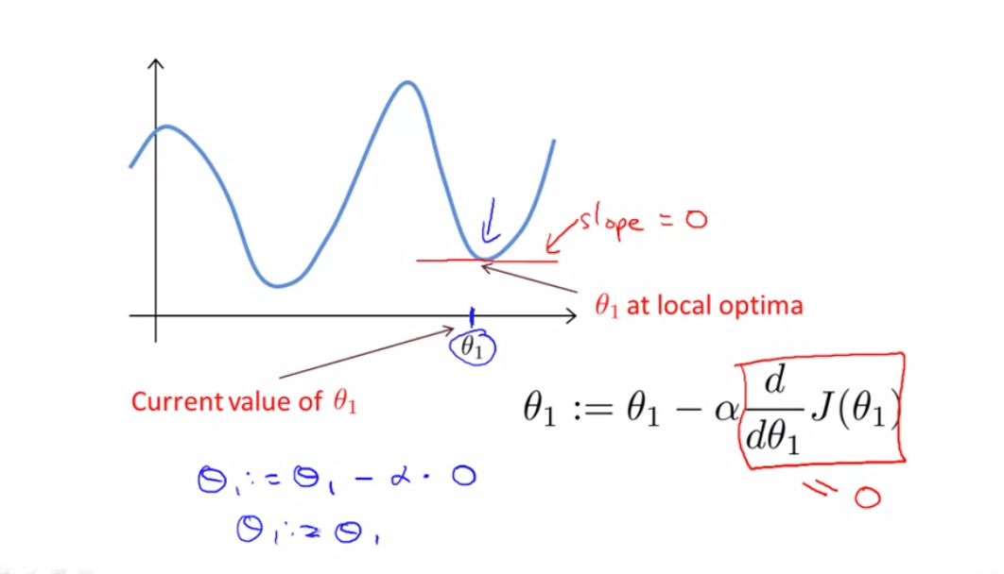

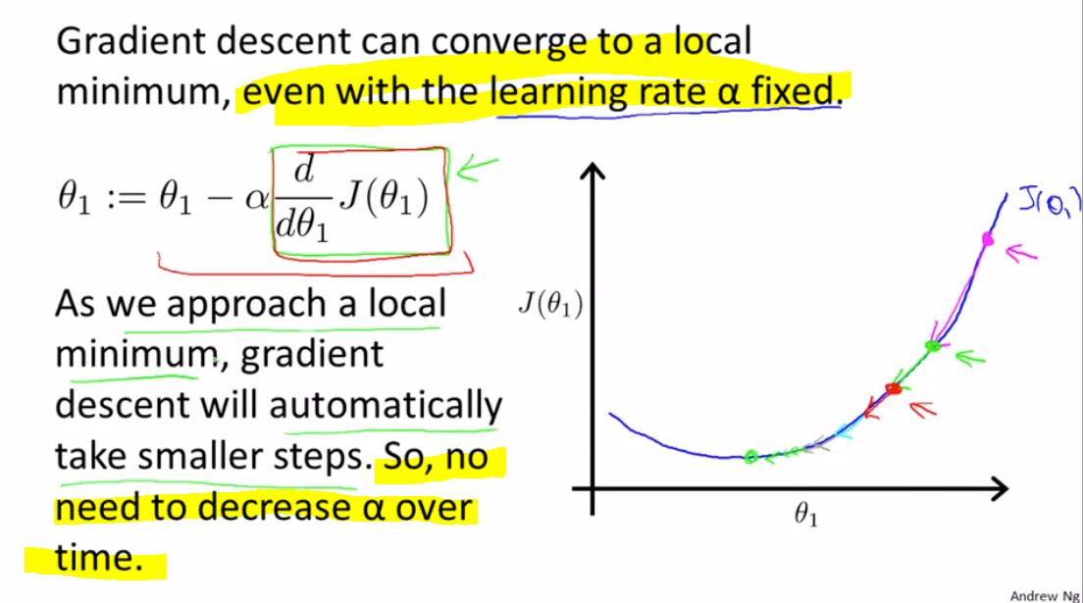

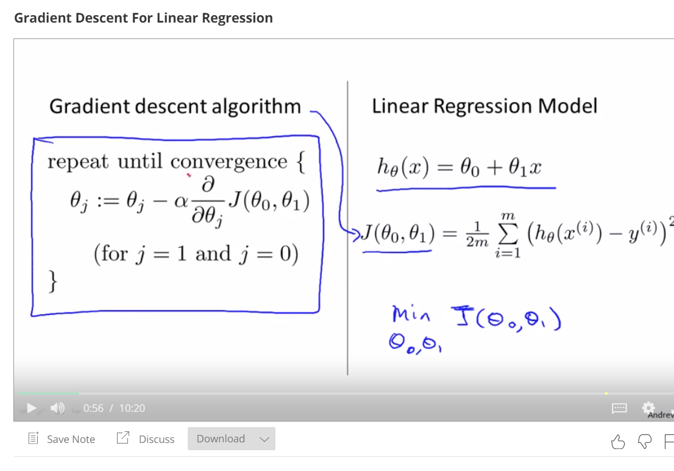

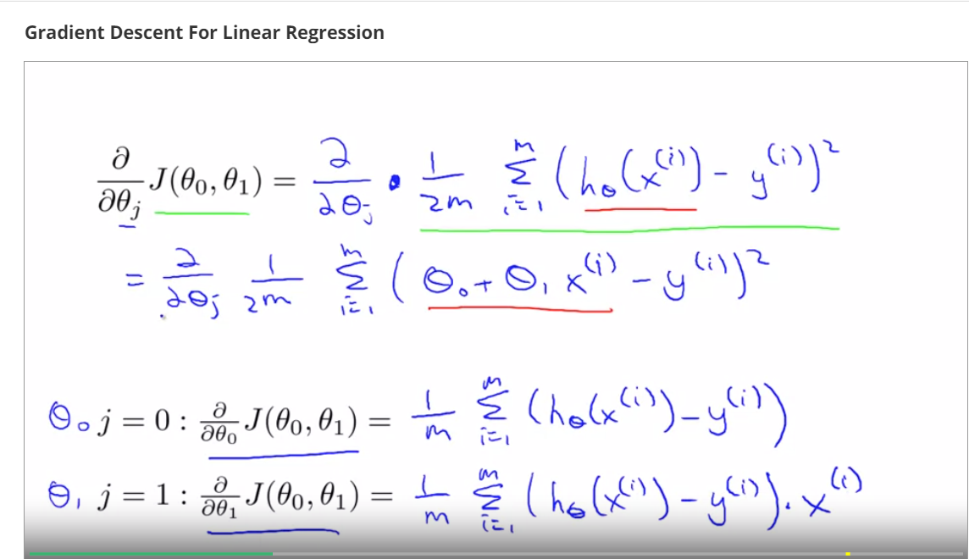

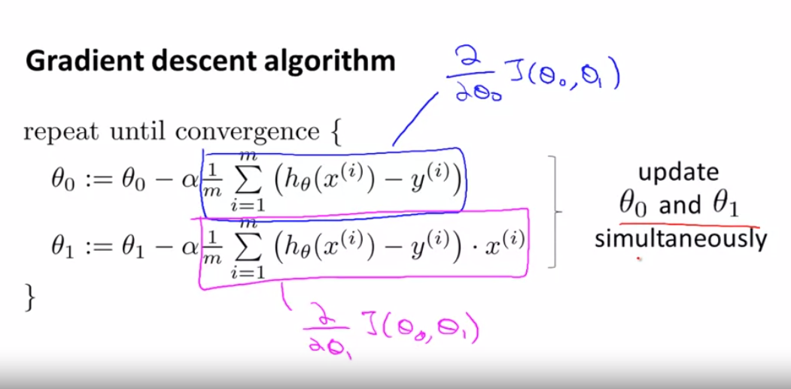

Let's see how gradient descent works. One of the issues we saw with gradient descent is that it can be susceptible to local optima. Depending on where you initialize it, you can end up at different local optima. But, it turns out that that the cost function for linear regression is always going to be a bow shaped function like this. The technical term for this is that this is called a convex function.

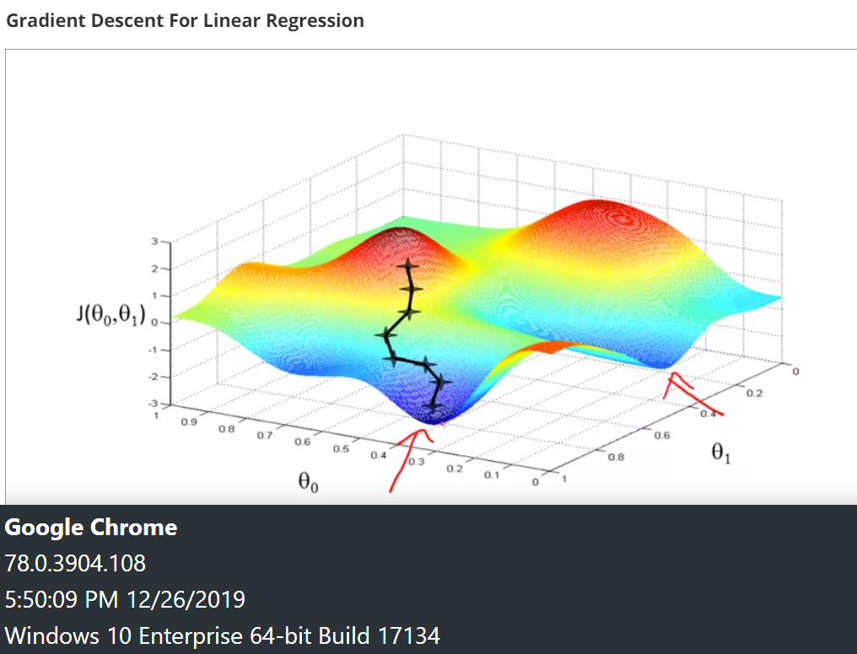

The bowl shaped linear regression cost function will always converge to the global optimum.

Because there are no other local optimum, only global optimum

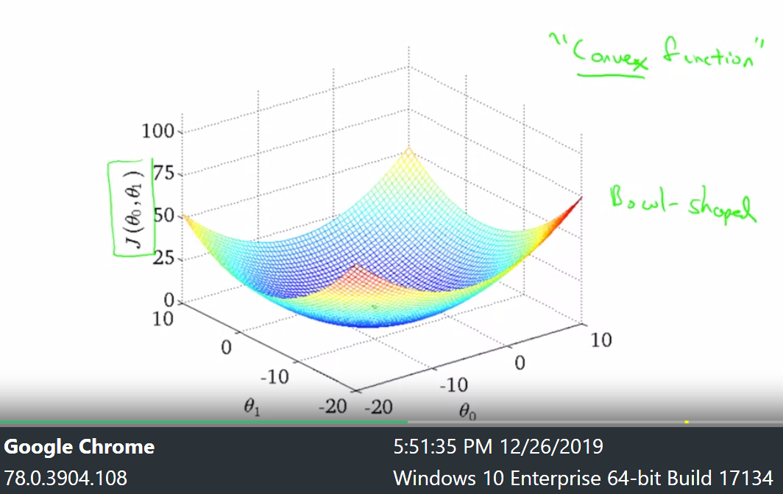

**Batch gradient descent Algorithm in action**

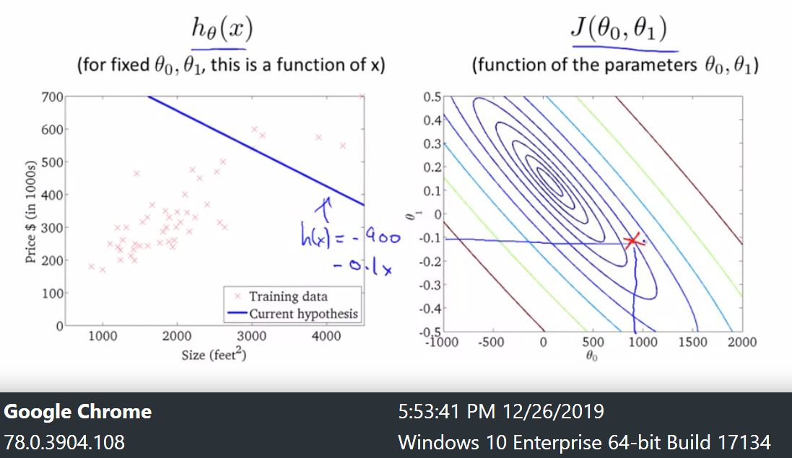

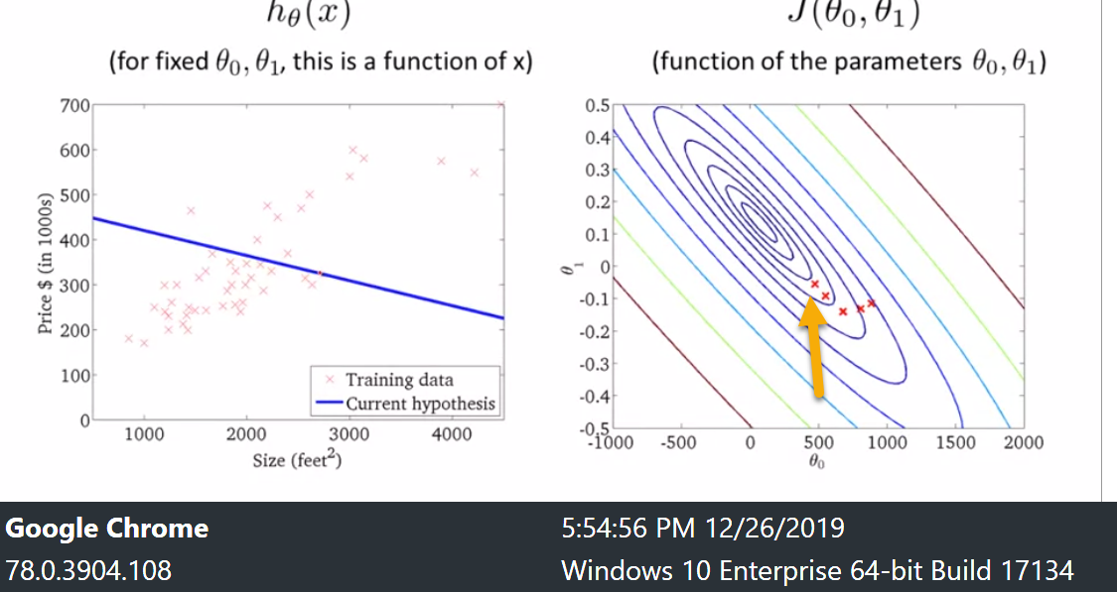

And as I take further steps of gradient descent, I'm going down in cost. So my parameters and such are following this trajectory. And if you look on the left, this corresponds with hypotheses.

That seem to be getting to be better and better fits to the data until eventually I've now wound up at the global minimum and this global minimum corresponds to this hypothesis, which gets me a good fit to the data.

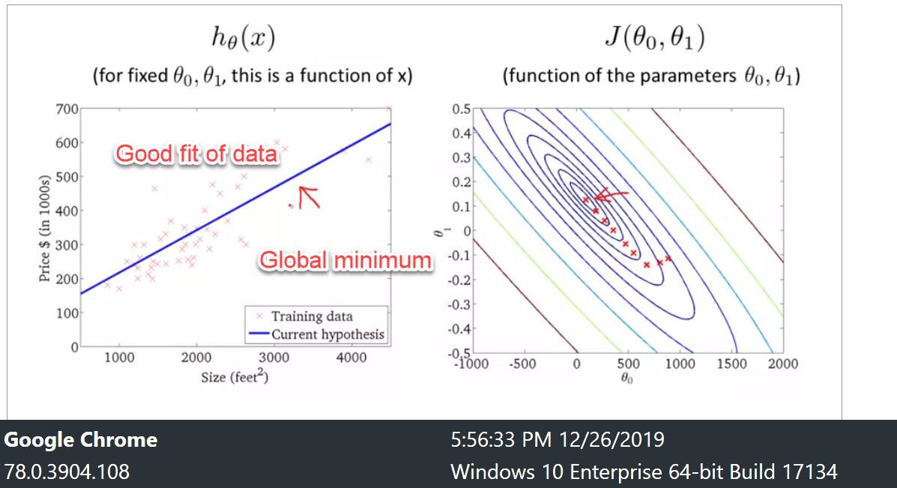

And so that's gradient descent, and we've just run it and gotten a good fit to my data set of housing prices. And you can now use it to predict, you know, if your friend has a house size 1250 square feet, you can now read off the value and tell them that I don't know maybe they could

get $250,000 for their house.

